Article

IoT monitoring of tree ecosystem services in urban green infrastructures: possibilities and challenges

Victor Matasov 1,*, Alexey Yaroslavtsev 1,7, Giovanna Sala 1,2, Olga Fareeva 1, Ivan Seregin 1,7, Luca Belelli Marchesini 1,3, Simona Castaldi 1,4, Viacheslav Vasenev 1 and Riccardo Valentini 1,5,6

1 Department of Landscape Design and Sustainable Ecosystems, Agrarian-Technological Institute, RUDN University, Miklukho-Maklaya str., 6, 117198, Moscow, Russia ; e-mail@e-mail.com

2 Department of Agricultural and Forestry Science, University of Palermo, Viale delle Scienze, Ed. 4, 90128 Palermo, Italy; e-mail@e-mail.com

3 Department of Sustainable Agro-ecosystems and Bioresources, Research and Innovation Centre, Fondazione Edmund Mach, San Michele all’Adige, Italy; e-mail@e-mail.com

4 Department of Environmental, Biological and Pharmaceutical Sciences and Technologies, Campania University “Luigi Vanvitelli”, Via Vivaldi 43, 81100 Caserta, Italy; e-mail@e-mail.com

5 Department for Innovation in Biological, Agro-Food and Forest Systems, University of Tuscia, Via S.M. in Gradi n.4, 01100 Viterbo, Italy; e-mail@e-mail.com

6 CMCC Foundation, via Augusto Imperatore, 16, 73100 Lecce, Italy; e-mail@e-mail.com

7 Department of ecology, Russian Timiryazev State Agrarian University, Moscow, Russia; e-mail@e-mail.com

**\*** Correspondence: matasov-vm@pfur.ru

Received: date; Accepted: date; Published: date

**Abstract (300 words MAX!):** Urban green infrastructures play an increasing significant role in sustainable urban development planning as they provide important regulating and cultural ecosystem services. Due to the dynamic nature of green areas, the monitoring of the services they provide for human well-being and environmental sustainability is challenging. Also, the central role that such services might have for urban decision-making and citizens’ consensus requires technological solutions which provide easy to end data collection, processing, and utilization at affordable costs. To meet these challenges a pilot study was conducted in the Moscow metropolis area using a network of wireless, low cost and multiparameter monitoring devices for single tree ecophysiologial endpoint monitoring aimed at testing the feasibility of the proposed technological solution to provide real-time monitoring of regulatory ecosystem services in form of meaningful indicators for both human health and environmental policies.

The pilot study was set in a green area situated on the island Balchug in the center of Moscow, which exposed to the heat island effect as well as to high level of anthropogenic pressure. Sixteen TreeTalker devices were installed to monitor from 1 July to 31 November 2019 the ecophysiological parameters of trees with a time resolution of 1.5 hours. These parameters were used as input variables to quantify indicators of ecosystem services related to climate, air quality and water regulation.

Our results show that the average tree in Moscow center during investigated period reduced extreme heat on 2℃ degree via shading, cooled down the surrounding area by allocating 2167± 181 KWh of incoming solar energy into latent heat, transpired 161± 21 mm of precipitation water, sequestered 8.61± 1.25 kg of atmospheric carbon and absorbed 5.3±0.8 kg of PM10. But the values of the monitored processes vary spatially and temporally when considering different tree species (up to five-ten times), local environmental conditions, the seasonal course of weather factors. Thus, it is crucial to use real-time monitoring data to understand deeper the processes in urban forests. There is a new opportunity of applying IoT technology not only to measure trees functionality through fluxes of water and carbon, but to establish a smart urban green infrastructure management providing ecosystem services indicators.

**Keywords:** ecological engineering, real-time monitoring, smart cities, sustainability, TreeTalker, trees, urban forests, ecosystem services indicators.

1. Introduction

Urbanization is increasing on a global scale, with more than half of the world's population living at present in cities, expected to arrive to two thirds by 2050 [1], driven by positive factors like economic opportunities and higher level of innovation and technology [2]. On the other hand, the urban development and population concentration do not follow in most cases sustainability criteria, resulting in growing health risks [3,4] energivorus systems significantly contributing global carbon emissions, ecosystem degradation and biodiversity loss on a global scale [5,6]. It is well-known that urban ecosystems are heterotrophic ecosystems depending on the natural capital and provisions from ecosystem services of extra-urban areas [7–9]. Conversely, the role of ecosystem services within the boundaries of the urban areas is still open to investigation to clarify many aspects of uncertainty and to identify the most representative ecological functions with describe meaningful ecosystem services for different targets [10–14]. Among the different ecosystem services offered by nature, regulatory and cultural services are the most interesting aspects in urban areas, at the core of the scientific and policy initiatives on green infrastructures in urban areas [15,16].

Urban green infrastructure (UGI), and trees in particular, play an essential role in the sustainable functioning of urban ecosystems and provide the most important regulating and habitat ecosystem services such as carbon sequestration, microclimate formation, pollution and dust reduction in atmospheric air, water balance control, wildlife habitat, wind and noise reduction, etc. [11,12,15]. The magnitude of the ES provided depend on the characteristics of UGI, such as vegetation type, age, structure and management practices, which is important for comparing to natural ecosystems [10,17–19].

Although the concept of “ecosystem service” has made much easier for common citizens, policymakers and urban planners, to understand the advantages offered by the green urban infrastructures, several limits to the operational definition and quantification of such services still remain [20,21]. This is particularly true for regulatory services for which it is necessary to identify and quantify a functional relationship between specific features of the green structure and environmental variable increasing human well-being and planetary sustainability. Such functional relationships need to be translated into ecosystem services indicators which are relevant (R) for their specific purpose, sensitive (S) enough to capture meaningful variation for health and environmental planning, clearly linked (L) to measurable policy targets and communication strategies, but most of all easy to monitor (M) [16,22–25]. Combining an adequate RSLM strategy into appropriate temporal and spatial scale of ecosystem service analysis of green infrastructure requires optimal technical solutions which are “user friendly”, i.e. which can be offered to not-scientific operators and decision makers of municipalities, in form of continuous and real-time data which can be collected and managed with minimal effort by the users. An additional relevant aspect is the economic feasibility of large scale monitoring systems like those which could be required in urban areas where a wide distribution of measuring stations might be necessary to cover the complex spatial variability of the city[14].

The fast growing fields of Information and Communication Technologies (ICTs) and Internet of Things (IoT) tools provides new and original ways to wire nature into “smart” monitoring systems. Smart technologies have been used in many environmental management programs, such as mapping changes in vegetation composition and structure [26], managing forest regeneration with precision farming [27], running and regulating at-distance greenhouse systems with wireless sensor networks [28,29], monitoring urban noise pollution with acoustic sensors [30,31].

This work presents the results of a pilot study which was conducted in the Moscow metropolis using a network of wireless, low cost and multiparameter monitoring devices to monitor single tree ecophysiologial parameters, the TreeTalkers (TT+) [32]. The study aimed at testing the feasibility of the proposed technological solution to provide real-time monitoring of regulatory ecosystem services relevant for both human health and environmental policy targets, reported in form of meaningful indicators for potential end-users of the municipality. This is particular relevant since the New Moscow Development Project, adopted in 2012, is continuing to expand GUI as result of active urbanization on an area of more than 1,500 km2, the impact of which on soils and ecosystems services is already visible [33] and its monitoring and operational management is greatly required.

2. Materials and Methods

2.1. Study site and network setup

With a population of over 12 million people, Moscow is the largest metropolis in Europe. The urban vegetation is made of species characteristic of the South Taiga zone, mainly preserved in urban parks, and introduced species such as linden, maple, willow, ornamental forms of trees and shrubs. According to the Köppen climate classification, the climate in this area is a humid continental climate. The study site is a green infrastructure created in 1948, located in the Bolotnaya square in central Moscow 600 m to the south from the Kremlin, on the island Balchug. The area is under the high influence of urban heat island and high level of anthropogenic pressure. The area covers about 4.5 hectares (Figure 1).

|  |
| --- |
|  |

**Figure 1.** Study area.

The nearby Balchug meteorological station (700 meters distance) provided meteo data at 3 hours frequency. The daily mean temperature varies between min °C in month x and max °C in month y, the amount of precipitation is rather high with an amount of 700 mm/year, mainly in the summer months.

The TreeTalkers devices (TT+) (Nature4.0 BC URL: www.nature4.org, [32]) are microprocessor based IoT platform built around the ATMEGA328p (Atmel Corp) chip, equipped with a LoRa transceiver for radio transmission to a central gateway which collect the individual tree data and send to cloud using GSM/GPRS technology. The TT+ sensors are able to measure: 1) the sap flow density, using a transient thermal dissipation methods based on an heating/cooling cycle of 10 minutes every 1.5 hour [34], 2) the light transmission spectra through the canopy in 12 spectral bands , using 2 spectrometers (VIS and NIR), 3) diameter growth with an optical IR pulsed device, 4) Stem position and oscillation in 3 axis with an on board accelerometer. In addition air temperature and humidity is recorded at the single tree level. Specifications and pictures are listed in Table 1 and Figure 2, respectively.

**Table 1.** Measured parameters according to TT+ specification.

|  |  |  |
| --- | --- | --- |
| **Sensor** | **Range** | **Accuracy** |
| Accelerometer | 0-360° (0-8g) | ± 0.01° |
| Diameter growth sensor | 0-1 cm | ±200 µ |
| Temperature probes | -40 ÷ +40 °C | ±0.1 °C |
| Stem humidity probe | 0 – 100% | ± 2% v/v |
| Visible Spectrometer | 400-700 nm | ± 5 nm peak  ± 20 nm HBW  (450,500,550,570,600,650 nm) |
| Near-Infrared Spectrometer | 700- 900 nm | ± 5 nm peak  ± 10 nm HBW  (610,680,730,760,810,860 nm) |
| Air and humidity sensor | -10 ÷ +85  0-100% | ± 0.5 °C  ± 5% |

|  |  |
| --- | --- |
| C:\Users\martin\Downloads\testFigure.tif  (a) | (b) |

**Figure 2**. (**a**) Scheme of TT; (**b**) its installation on a tree.

Sixteen TreeTalker+ (TT+) devices were installed on corresponding trees of five different tree species: 5 on *Acer platanoides* (average DBH 38.7 cm), 3 on *Betula pendula* (average DBH 21.8 cm), 3 on *Larix sibirica* (average DBH 32.1 cm) and 5 on *Tillia cordata* (average DBH 34.1 cm). At onset of installation, all trees were characterized by height, diameter, age group, standing type and VTA (Visual Tree Assessment). The investigated trees VTA scores were (1 to 3), on a typical scale from 1 (healthy conditions) to 7 (severe decline), (see Appendix A). A reference device TT+ (TT-R) was mounted outside of the tree canopies to collect climate data and incoming solar radiation reference spectra. On individual trees, the devices were placed at a height of 3 m from the ground on the north side of the trunk and the solar powered batteries - on the south side. The 3 m height was chosen to reduce the risk of damage or theft of devices. All measurements were conducted from 01 July till 31 November with 1.5 hour temporal resolution.

2.2. Choice of ES Indicators

A wide range of existing ES indicators has been investigated in previous studies [11,35]. For the present study the ES indicators were chosen on the basis of the possibility to be directly estimated by our measured parameters and they fulfill the RSLM criteria previously indicated The ES indicators and the relative measured variables, including algorithms references are shown on Table 2. Direct measurements (like air temperature or relative humidity) gave us an opportunity to calculate ESI without any additional assumptions. However, all the ESI that is labeled as “indirect” required us to introduce some adjustment factors or assumptions. One of the best “indirect” predictor of ES is tree Leaf Area Index since many ESI can be estimated by the amount of leaf area. For the purpose of this paper we have monitored LAI in real time by using the 2 on-board spectrometers and we present particulate adsorption as an example of usefulness of LAI indicator indirect use.

**Table 2**. Indicators of ES, provided by urban trees and potential measuring quantity by sensors

|  |  |  |  |  |  |  |
| --- | --- | --- | --- | --- | --- | --- |
| **ES group** | **Type of ES** | **Indicator** | **Sensor** | **Type of equation** | **Units** | **Key references** |
| Global Climate regulation | Carbon sequestration | Tree growth rate | IR growth sensor | Indirect  *Biomass expansion factors* | kg C | [36–38] |
| Local Climate regulation | Climate comfort regulation | Air temperature | Thermo-hygrometer sensor | Direct | C degrees | [39–41] |
| Humidity | Thermo-hygrometer sensor | Direct | % | [42,43] |
| Wind velocity | Spectrometer | Indirect  *LAI* | m s-1 | [44–46] |
| Energy balance regulation | Latent energy via transpiration | Sap flow sensors | Direct | W m-2 | [47,48], |
| Water regulation | Run-off mitigation | Transpiration | Sap flow sensors | Direct | l hr-1 or mm | [43,49–51] |
| Rain buffer | Spectrometer | Indirect  *LAI* | % | [52–54] |
| Air quality regulation | Particulate adsorption | PM removal | Spectrometer | Indirect  *LAI* | g m-2 | [18,55–57] |
| Gas regulation | Gaseous pollutants removal | Spectrometer | Indirect *LAI* | g m-2 |

2.2.1. Carbon sequestration

Carbon sequestration assessment was based on IPCC 2003 approach utilizing biomass expansion factors (BEF):

|  |  |
| --- | --- |
| , | (1) |

where ΔV is tree stem volume (m3); BCEF is Biomass Conversion and Expansion Factor obtained using this formula BCEF = BEF * ρ where BEF is biomass expansion factor to obtain the total above-ground biomass and ρ is density of the wood (kg/m3); R is ratio between below-ground and above-ground biomass; CF is the carbon fraction of the dry mass (conventionally equal to 0.5 as suggested by IPCC (2003).

The BCEF and R was taken from literature according to species and age of the tree [58], CF (biomass conversion into carbon) was taken as 0.5. Trunk volume (V) was calculated using height measured directly in field and basal area increment (BAI according to LeBlanc, 1992).

|  |  |
| --- | --- |
| , | (2) |

where *w* is trunk diameter expansion measured in real time with TreeTalker+ IR distance sensor. Stem dendrometric coefficients for different species have been taken into account for the estimation of the trunk shape in the final calculation of biomass increment.( IPCC, 2003).

2.2.2. Climate regulation via air temperature and humidity

We have used direct measurements of temperature and humidity changes based on the difference between data form thermo-hygrometers of individual TT, measuring climate parameters at 3 m height under the crown space and TT-R (reference outside station). Temperature and humidity measurements were taken by the TT device with a measuring cycle of 1.5 hours as for all the other parameters.

2.2.3. Water fluxes and energy consumption through transpiration

The transpiration rate of whole plants is closely approximated by the sap flow rate in the main stem or trunk. We implemented in the TT platform the Thermal Dissipation method, firstly developed by Granier [59]. Granier original method is based on the dissipation of a heated probe in relation to a reference one in proximity (about 10 cm in our case), with continuous heating. The need of reducing of energy consumption in field operations have raised up modifications of the thermal dissipation method to include the possibility to use heating and cooling cycles, which reflect in a better accounting of thermal gradients and at the same time reducing the power requirements. In this experiment we have used the approach of Do et al. [34,60], with a heating cycling of 10 minutes, while data are sent every 90 minutes to the server. The heated and reference probes of TT+ are installed into the tree trunk at the vertical distance of 10 cm. The probes have a diameter of 2.5 mm each and are installed at the depth of 2.5 cm. The TT+ heat dissipation probe is installed on the northern side of the trunk at the 3.5 m height and is well protected from direct sun heating by the canopy. The sap wood area for each tree was assessed by using literature data on its relation with tree diameter (Daley et al., 2007; Gebauer et. al, 2008; Thurner et al, 2019). Sap flow was calculated with the assumption that the whole trunk sapwood area was conducting water. It was assumed that daily transpiration is equal to daily sum of sap flow.

The energy absorbed by tree for transpiration was calculated on the basis of the equation:

|  |  |
| --- | --- |
| L= T , | (3) |

where  is energy spent in transpiration ( the latent heat for vaporization of water = 2264.705 KJ/Kg), T – transpiration, which was assumed equal to sap flow.

For what concern potential runoff mitigation of urban trees, we have considered, as Ecosystem Service indicator, the ratio of transpiration (T) to precipitation (P):

|  |  |
| --- | --- |
| Rp = T/P, | (4) |

where both terms are calculated using mm. Tree level transpiration has been recalculated per unit of crown area. In principle evaporation can be calculated by simple meteorological models and canopy interception through LAI, but in the present paper we propose a simple approach to derive a runoff mitigation indicator, represented by Rp.

2.2.4. LAI

There are a lot of different methods and protocols to estimate LAI [61,62]. According to Monsi and Saeki (1953) light transmission through canopy as porous media can be treated according to the Beers law. In this way LAI can be estimated by the extinction of photosynthetic light radiation through the canopy [63]. Photosynthetically active radiation was measured above and below canopy (with TT-R and TT+ spectrometers, respectively). Since the light is blocked also by woody components of canopy (i.e. branches and twigs), the extinction of light profile gives the PAI (Plant Area Index) as follow:

|  |  |
| --- | --- |
| . | (5) |

PAI consists of wood area index (WAI) and leaf area index (LAI). Assuming that WAI is constant throughout vegetation period and LAI = 0 after defoliation (second part of October and November), WAI for each tree was calculated as mean PAI of November*.* Light extinction coefficient k was calculated per each species utilizing LAI light measurements at rhe foliage peakwith hemispherical photo done with Kodak PIXPRO SP360 and Hemisfer software (Thimonier et al., 2010).

2.2.5. Particulate adsorption

Dry deposition of solid particles on canopy was calculated according to i-Tree Eco Dry Deposition Model [56]:

|  |  |
| --- | --- |
|  | (6) |

where C is the PM10 concentration (g m-3), Vd the velocity of deposition (m s-1), LAIPM10 the leaf area index for pollutant deposition (m2m-2) and VdPM10max,VdPM10avg,VdPM10min – maximum, average and minimum deposition velocity for PM10 – 0.0064 ms-1, 0.0025 ms-1, 0.01 ms-1, respectively. Values were multiply by canopy area to show adsorption per individual tree. Pollutant concentration was obtained from nearby open access pm10 sensors via sensor.community web portal in Moscow (<https://sensor.community>).

2.3. Data processing

Data collection with TreeTalker+ devices is organized according to the following scheme. All types of devices (TT+ and TT-R) made measurement every 90 minutes, stored data in internal memory, and then according to predefined time window transmitted data to the gateway (TT-cloud) device via Low Power Wide Area Network (LoRa) wireless networking protocol. TT-cloud device is a gateway, which purpose is to collect data from all TT devices on site, store it and then transmit it to online database via WiFi or wireless mobile networks.

All remote data were collected and processed with R computing language [64]. Field data was organized in a table and added to computation on early stages of processing. All weekly measured parameters were filtered by excluding 3 sigma (standard deviation) data. Filtered data was linearly interpolated. Data from TT devices didn’t have gaps more than three days (due to some battery problems). Data were filled with data from trees with closest parameters (species, trunk diameter, height, canopy size, position on site).

3. Results and discussion

3.1. Carbon sequestration

Carbon sequestration is the result of continuous diameter increment across the season and relative biomass accumulation was calculated using equation (1). The growth dynamics show biomass increase till the end of September (around 260 day of a year) due to the warm autumn (Figure 3).

|  |
| --- |
|  |

**Figure 3.** Cumulative grow of stored carbon for species, whiskers denote standard error.

Birch growth rates decreased two weeks later than others, with less variability across individuals, possibly because of more uniform young age. Betula growth rates range form 2.19 to 2.79 Kg C per tree along the season and they represent the lowest values among the investigated trees. Acer growth rates range from 8.35 to 15.3 Kg C per tree along the season with a moderate variability. Linden growth rates are slightly lower than Maple ranging from 1.76 to 6.27 KgC, showing a marked individual variation. Larch trees represent show similar growth rates with values ranging from 4.95 to 7.66 kC per tree.

In total the average accumulated carbon (during half of the vegetational season) per tree for the investigated species are11.58±1.47 Kg C (*Acer platanoides*, ± standard error ), 1.5±0.15 Kg C (*Betula pendula*), 6.03±1.31 Kg C (*Larix sibirica*), 10.89±2.89 Kg C (*Tilia cordata*).

We have furthemore compared the seasonal growth rates with the mean annual increment derived by the total estimated biomass, derived by the biomass expansion factors equation and divided by the tree age. Not with standing the uncertainty on age of about 5 years, the current increment estimated by the diameter optical growth sensor is comparable with the annual mean increment (Appendix A). In particular the former is higher as usually reported for tree ages before full maturity.

In general our knowledge of urban tree carbon dynamics, including the balance of growth, mortality, and planting rates is quite data limited [36]. Although the carbon stock of the urban green is smaller compared to natural forests, the storage capacity is considerable high [65]. Growth rates of urban trees may be accelerated by the heat island effect, as result of increasing temperature, longer growing season and potentially higher N deposition, as it was shown by [66]. The observed diameter growth for the different species, although is rather variable across individuals, are consistent with the existing literature, showing for *Picea* and *Birch* a range of 1-3 mm of annul growth [67,68] in the same age range. Conversion of diameter growth in biomass and hence carbon sequestration is very much related with the BEF coeffcients which we have derived by [58], specifically for the Russian environment. One of the most comprehensive study on urban tree carbon sequestration is the one across a wide range of US cities [36]. These authors showed an average annual net carbon uptake per tree of about 0.226 m-2 year-1. Scaling larch trees carbon sequestration per unit of crown area we obtain an average value of 0.14±0.04 kg C m2 per half of vegetation period, which is the closest result in relation to Nowak et al., while for broad leaved species this paramater was more than two times higher (with max of 0.48±0.14 kg C m2 per half of vegetation period for *Acer platanoides*). Although is difficult to compare our data with existing annual growth rates, due to the lack of full season data coverage (about 4 out of 6 months) our data show a reasonable consistency with inventory data and existing literature, (WE NEED TO FIND SOME MORE LITERATURE ON CARBN SEQUESTRATION BY TREES)but more importantly they confirm the possibility to monitor in real time carbon sequestration as one of the most significant ecosysem service of urban trees.

3.2. Air Temperature and Humidity control

The local climate control from ecosystem service perspective is the mitigation of extreme temperatures and providing comfort urban microclimate. In Figure 4 the diurnal difference mean changes of temperature between the reference station and the space under the tree crown is presented as mean monthly day, for the investigated species. During the day the temperature difference is maximal, peaking on early afternoon in July, August and September, with the contrasting difference of October when the dynamic is reverted. During the day trees are cooling the surrounding air via shading, showing an effect up to about 2°C degrees with the external temperatures (Appendix B). In October all the species show a warming effect at mid of the day, on the same order. An opposed behavior is recorded for nighttime periods where usually during summer months trees are slightly warmer than the surrounded air. In October they show a cooling effect in the night.

|  |
| --- |
|  |

**Figure 4.** Diurnal differences mean changes of temperature by month averaged for all the investigated species.

The average differences between the air relative humidity under and outside of the canopy were not more than 20% (Appendix C). During daytime trees made air more humid, while during nights they reduced humidity. There were no seasonal changes through months, even no significant difference between species. We can only see the typical sinusoid line with delay in time as a result of transpiration process.

Another important effect of trees is the mitigation of climate extremes. For this purpose we have estimated the daily differences between maximum and minimum temperatures of the reference station and the individual tree recording (Figure 5). While temperature amplitudes outside of the canopy (the black line) reached a maximum of about 10°C degrees in August, under the canopy this amplitude was 3°C degrees lower. All the species showed similar dynamics through the investigated period, but under the larch temperature extremes were more similar to the reference station both during summer and particularly during fall after defoliation.

|  |
| --- |
|  |

**Figure 5.** Daily maximum amplitude differences between reference station TT-R (black line) and TT+.

These findings correspond well to [43], who explained observed seasonal dynamics of temperature reduction rates by differences in transpiration and to [69], who also found that within the canopy radius of 4.5m of Acer platanoides or Tilia cordata trees, daytime temperature decreased up to 3.5 ℃ during August in comparison of the unshaded surrounding area. Our results go in a line with the meta-analysis study, which showed relations between individual tree characteristics and daily/seasonal temperature reduction dynamics in different climate and urban conditions [69]. Temperature reduction by urban green infrastructure on about 0.5-2.5℃ degrees was also shown in several papers, which used computational modeling [41,70] and satellite based data such as land surface temperature [71,72].

3.3. Run-off mitigation and energy consumption by trees via transpiration

In Appendix D we present an ensemble of transpiration daily patterns for the investigated individuals which show the typical diurnal behavior modulated by changing environmental parameters. The ensemble of data also show a variation on the onset and the peak of transpiration cycle across the individuals, particularly in maple and linden, showing the variation of conditions to sun exposure. Sap flux during night for all individuals was negligible, while during the day it raise up to 3 lh-1 for birch trees and even 5 for several limes and maples trees in July. Maximal values of daily flux were detected for all species in July, and reached 8 lh-1 for *Larix sibirica*, 7.6 lh-1 for *Acer platanoides*, 5.9 lh-1 for *Tilia cordata* and 3.8 lh-1 for *Betula pendula,* while average daily flux for those species in July was 2.90±0.08, 2.85±0.08, 2.18±0.05 and 1.74±0.04 lh-1, respectively. In later moths of investigation sap flux values was gradually decreasing for all species.

For the purpose of the current study we report the cumulated transpired amount of water in relation to seasonal rainfall. The units are expressed in mm of water where for each of the tree, transpiration rates have been converted in mm by using the tree canopy area. The main purpose is to show, from ecosystem services perspective, the possibility of a tree to serve as a sewage system to mitigate flooding from rains. Our results show that maple and lime trees reduced 130 ±50 mm (± standard error) of water through the investigated period, larch trees 90±50 mm, while young birch –300±50 mm (Appendix A, Figure 6). In general, this cumulative process was mostly linear with some differences in rates that can be associated with different VTA scores and standing conditions. On the other hand, there were no significant response to the heavy rains. According to our data we can say that up to 165±0.16% (± standard error)of precipitation can be transpirated per square meter of canopy (*Betula pendula,* supposedly due to age of investigated birch trees), while mature broad leaved trees could transpire 95±11% and 84±11% of precipitated water for *Tilia cordata* and *Acer platanoides*, respectively; the only investigated coniferous species showed minimal values 57±19%..

|  |
| --- |
|  |

**Figure 6.** Average transpiration per species compared to precipitation (black line), whiskers denote standard error.

For investigated period the ability of individual trees to transpire precipitated water volume around them positively correlates with size and density of those species canopies, that correlates with similar works [73,74]. Taking into account density of the stand it can be assumed that for investigated plot annual rainfall and transpiration could be close for years without extreme rainfall ranges, what was shown for boreal urban trees of other cities [49,51]. Such information obtained in real time could considerably contribute to cities stormwater management [75–77]. It is widely discussed that rain interception for run-off mitigation consists from several important parts, e.g. leaf buffering during heavy rains [54,78,79], which is also based on leaf area index.

Using the energy balance equation (3) it was possible to estimate the amount of absorbed radiation that is subtracted from the environment due to transpiration. Diurnal graph shows the increase of the absorbed latent heat (L) during daytime when transpiration starts following the sun rise (Figure 7). Daily range of adsorbed energy during July and August was 0.5-2.2 kWh for maple, larch and lime trees, while for birch it was a bit lower (0.2-1.5 kWh). Already in September there was a decrease in absolute numbers below 1.2 kWh for all species, but the range for maple was 0.6-1.2 kWh, and for birch again on a level of 0.1-0.6 kWh. On contrary during October and November the lowest values were shown by maple trees (with a range 0.1-0.2) while for all other species it was 0.2-0.8 kWh. In average during the investigated period we got 2471.2±266 kWh (± standard error) of energy accumulated by maples, 1379.4±436.7 kWh – by birch, 2140±676.8 kWh – by larch and 2221.7 ±385.4 kWh – by lime trees. Also, the differences between individuals are noticeable (Appendix E).

|  |
| --- |
|  |

**Figure 7.** Diurnal dynamics (top) of Latent heat (L) and sap flow for different species averaged per month.

Trees energy latent het fluxes varied between species, individual trees and seasons. Authors state that main variability between individual trees was due to the difference in size of the canopy and position of the tree in the plot. Nevertheless, there are not much publication about energy balance of boreal urban trees, however we got comparable number for lime in summer months [73].

3.4. LAI as a proxy for several ES

The LAI dynamics is very important since it is a good proxy for several types of Ecosystem Services, such as wind velocity and noise reduction, pollution regulation and erosion protection via leaves as a buffer. From our radiation sensor we can calculate the overall plant area index (PAI) that is just a sum of leaves and wood (bark) light interception effect. Thus, after comparing periods with and without leaves we can derive both leaf and wood area index. These periods are clearly visible in Figure 8 where we can easily distinguish the time of defoliation which lasted one week in first days of October. It is interesting to note that for an individual tree this process can take in reality one-two days. Only due to our perception of green areas as a whole, often derived by airborne images, we think this process has a slower dynamic. As a result, average LAI of all trees (Appendix A) was 3.77 with less range in Betula (3.5-3.7) and higher variation for Acer (3.2-4.3) and Tillia (3.4-4.3). For Larix range was 3.6-3.9, despite our expectations for higher values, which difference can be explained by the higher insertion of the crown.

**Figure 8**. PAI dynamics averaged per species during investigated period (July-November, 2019), whiskers denote standard error.

Despite the well described dynamics, Leaf Area Index, estimated by the spectrometer was influenced by the angle of view of the spectrometer, which is ± 10° and positioned in the North side of the trunk, thus recording only one section of the crown. For a better absolute determination it is necessary to compare the sensor with more precise technics (e.g. camera with fish-eye lens or other LAI meters) which are essential for calibration and validation [62,80]. But the absolute values (3-4) are comparable to most of the papers [62,63,81] in similar species. While the strong correlation between LAI and DBH and also between LAI and tree height was shown previously for Canadian and Bavarian boreal forests [81,82] our results did not allow us to confirm this, that is possible explained with small amount of trees in consideration and urban conditions [83]. However the real time dynamics of LAI and WAI is the advantage of our device which is important for plant physiological processes and models based on it [84].

3.5. Particulate adsorption

Particulate adsorption is influenced by two main parameters – PAI and particulate concentration in air, according to the model described in Methods. The absorption dynamic during investigated period mostly reflected the changes in the air pollution level by particulate concentration, which shows peaks in the end of July and beginning of August, then in September and late November. While the reasons of this pollution dynamics were not in our focus, we can only say that the average absorption rates differ among investigated trees, due to their canopy area firstly. The lowest adsorption rates were shown by birch trees on an average level of 9.3 g per day, the highest were maple and larch trees 51.2 and 51.4 g per day respectively, while lime were in a middle with 25.5 g per day per tree (Appendix F). The highest adsorption peaks (in terms of maximum deposition velocity) were up to 1200 g (Larix) during several days with the high concentrations in the air. This parameter shows drastic variation across time. The cumulative particulate mass absorption over the season was 7.7 ±1.5 kg for Acer (± standard error), 7.7±2.1 kg for Larix, 3.8±0.2 kg for Tillia, and 1.4±0.1 kg for Betula (Figure 9, Appendix A).

**Figure 9**. Cumulative particulate adsorption (minimum, average and maximum) by tree leaves per investigated period (July-November, 2019).

Sæbø et al. [57] showed that Betula improves air quality by particulate adsorption much better than Acer and Tillia, that can be explained (in our case) just by the size of a tree. It is well known that healthy large trees remove about 60 times more pollution annually than healthy small trees [55]. And leaf wax or leaf hair density and topography also influenced much [57,85]. In our case we could not include leaf morphology or topography since our estimation was based on LAI. However the total adsorption by tree seems comparable with several works with an average 0.5-5 g m-2 rates of adsorption in different cities [18,86,87], which resulted in 10-200g daily per tree. Thus, our results from Moscow center with high traffic look comparable.

Conclusions

According to our findings we can summarize our results on ecosystem services estimation with an individual tree average of 8.61± 1.25 kg of Carbon stored (± standard error), 161± 21 mm of water transpired, 2167± 181 kWh spent for microclimate regulation and 5309±808 g of PM10 adsorbed per investigated period (July-November, 2019). These numbers could be easily transformed to monetary values with the use of local prices for each of the service.

There are several approaches to provide ecosystem services information for the green infrastructure in urban areas. However, most of the inventory types approaches, even when based on high resolution imaging, are limited by the temporal resolution which sometime is important for detecting an early onset of ES decline. Our results show that an IoT tree level network, using individual tree physiology sensing devices, such as TreeTalker, or other similar devices, can be used in principle for monitoring urban green infrastructure ecosystem services in real time. Furthermore, for some of the ES indicator, such as water and cooling effects, they are most often based on models with indirect derived parameters. Having real time and individual tree data can improve our predictions and urban green infrastructure planning. There are several advantages for increasing the granularity of ES monitoring, since individual trees can be managed with a greater accuracy. The cost of monitoring is therefore critical for IoT expansion in green infrastructure monitoring. In recent years technological development and low cost microprocessors, traditionally used in automation and industry processes (Industry4.0), are creating new opportunities for their expansion in environmental monitoring, that we could define as a Nature4.0 transformation [32]. An average cost of 200-300 Euro per point of measurements (tree), including the LoRa gateway, have been estimated in our experiment.

However, there are limitations and improvements to be considered in future work. First of all the power consumption of the TreeTalker devices, used in the current work, is still a big limitation. Batteries need to be replaced every 1-1.5 months which require still quite investment of labor work. New batteries are being developed with much larger capacity that in principle could extend the battery life duration. In terms of improvement a new IR sensor for remote sensing of canopy temperature could be very useful for improving the energy balance estimation and cooling effects. In particular, the installation of an anemometer will provide additional data on wind speed in the canopy, which influence much several ecosystem services. In addition simple PM2.5-10 optical devices can be included in the processor platform to get useful data on air quality using trees as monitor stations. In principle, but further studies need to be conducted, a noise sensor and microphone could also be included with the aim to provide useful information on the noise pollution and “soundscape” quality generated by trees in parks [31,88] and also to evaluate associated biodiversity with the help of recorded bird songs [30,89]. Nevertheless, the technical development of sensors along with people engagement to citizen science will be inevitable [28,90,91], thus it will be important to adapt them to the task of monitoring those parameters that are important for urban planning decisions [92].

Among the indicators presented in the article, perhaps not all of them can be used for practical purposes directly. Air temperature and humidity under the canopy of city trees can be presented “as is” for people, as well as wind speed for example. However, in order to monitor the quality of the urban environment associated with green infrastructure, it is probably worth developing specific scales of air quality, microclimate comfort and noise pollution levels – in this form it makes more clear information for citizens. On the other hand, for spatial planning tasks, it will be useful to create a urban tree database on annual or seasonal indicators of ecosystem services provided by tree species at its specific age, height and condition. This could be very useful for operational management of urban green infrastructures. [93]. In addition, it is also necessary to take into account disservices associated with urban trees such as the fall of weakened and diseased trees on cars, infrastructure and buildings, and the allergic reaction of people to tree pollen [94,95]. These parameters should also be continuously monitored and reported in real time for rapid response or timely prevention.

**Author Contributions:** Conceptualization and methodology, R.V. and V.M.; software, A.Y. and L.B.; validation, G.S., L.B.; investigation, G.S., L.B, O.F., I.S; data curation, A.Y.; writing—original draft preparation, V.M.; writing—review and editing, R.V. and S.C.; visualization, A.Y.; supervision, R.V.; project administration, V.V. All authors have read and agreed to the published version of the manuscript.

**Funding:** Monitoring and modeling ecosystem services of urban trees was supported by Russian Scientific Foundation Project # 19-77-300-12. Data processing and analysis was supported by “RUDN University program 5‐100”.

**Acknowledgments:** In this section you can acknowledge any support given which is not covered by the author contribution or funding sections. This may include administrative and technical support, or donations in kind (e.g., materials used for experiments).

**Conflicts of Interest:** The authors declare no conflict of interest.

Appendix A. Tree description and summative of ecosystem services produced by each tree per investigated period (July-November,2019)

|  |  |  |  |  |  |  |  |  |  |  |  |  |  |  |  |  |  |  |  |  |  |  |  |
| --- | --- | --- | --- | --- | --- | --- | --- | --- | --- | --- | --- | --- | --- | --- | --- | --- | --- | --- | --- | --- | --- | --- | --- |
|  | **Trees description** | | | | | | | | | | | **Biomass carbon** | | **Transpiration and precipitation** | | | **Energy asborbed** | **PM10 particles absorbed, g** | | | **Leaf and wood indexes** | | |
| **id** | **Age group** | **Tree height, m** | **Trunk diameter,cm** | **Trunk growth,mm** | **Canopy area, m2** | **VTA** | **BEF** | **BCEF** | **R/S** | **Total tree carbon, kg** | **Average annual tree carbon increment, kg** | **Carbon stored, kg** | **Carbon stored per canopy area, kg m-2** | **Transpiration, mm** | **Precipitation, mm** | **Ratio of precipitation evaporated, mm** | **L, kWh** | **PM10max** | **PM10avg** | **PM10min** | **PAI, m2m-2** | **WAI, m2m-2** | **LAI, m2m-2** |
| ***Acer platanoides*** | | | | | | | | | | | | | | | | | | | | | | | |
| **218A0077** | 50-60 | 20 | 35.65 | 3.36 | 55.7 | 2 | 1.31 | 1.05 | 0.317 | 580.02 | 10.55 | 12.95 | 0.23 | 83.59 | 183.5 | 0.46 | 2454 | 17976 | 11504 | 4494 | 4.81 | 0.47 | 4.34 |
| **218A0212** | 50-60 | 15 | 33.74 | 3.18 | 27.6 | 3 | 1.31 | 1.05 | 0.317 | 393.59 | 7.16 | 8.79 | 0.32 | 130.8 | 183.5 | 0.71 | 1615 | 7250 | 4640 | 1812 | 3.99 | 0.51 | 3.49 |
| **218A0255** | 50-60 | 20 | 34.38 | 3.24 | 55.3 | 2 | 1.31 | 1.05 | 0.317 | 559.75 | 10.18 | 12.5 | 0.23 | 92.1 | 183.5 | 0.5 | 2506 | 15065 | 9641 | 3766 | 4.26 | 0.42 | 3.84 |
| **218A0262** | 50-60 | 13 | 34.7 | 3.27 | 28.5 | 1 | 1.31 | 1.05 | 0.317 | 373.73 | 6.8 | 8.35 | 0.29 | 168.32 | 183.5 | 0.92 | 2739 | 7861 | 5031 | 1965 | 4.81 | 0.57 | 4.23 |
| **218A0281** | 50-60 | 14 | 45.84 | 4.32 | 35.8 | 4 | 1.31 | 1.05 | 0.317 | 684.96 | 12.45 | 15.3 | 0.43 | 190.09 | 183.5 | 1.04 | 3042 | 11940 | 7641 | 2985 | 3.64 | 0.43 | 3.21 |
| **Mean** |  | 16.8 | 36.86 | 3.47 | 40.58 |  |  |  |  | 518.41 | 9.43 | 11.58 | 0.3 | 132.98 | 183.5 | 0.72 | 2471.2 | 12019 | 7691.8 | 3004.6 | 4.30 | 0.48 | 3.82 |
| **SE** |  | 1.7 | 2.53 | 0.24 | 6.99 |  |  |  |  | 66.03 | 1.2 | 1.47 | 0.04 | 23.22 | 0 | 0.13 | 266 | 2302.1 | 1473.3 | 575.5 | 0.23 | 0.03 | 0.21 |
| ***Betula pendula*** | | | | | | | | | | | | | | | | | | | | | | | |
| **218A0104** | 50-60 | 11 | 21.65 | 2.72 | 7.6 | 1 | 1.19 | 0.761 | 0.219 | 80.41 | 1.46 | 2.39 | 0.31 | 242.16 | 183.5 | 1.32 | 1157 | 2029 | 1298 | 507 | 3.95 | 0.44 | 3.51 |
| **218A0210** | 30-40 | 11 | 21.01 | 2.64 | 6.4 | 1 | 1.19 | 0.761 | 0.219 | 73.7 | 1.34 | 2.19 | 0.34 | 304.4 | 183.5 | 1.66 | 1226 | 2046 | 1309 | 511 | 4.02 | 0.42 | 3.6 |
| **218A0285** | 30-40 | 11 | 23.87 | 3 | 8.2 | 1 | 1.19 | 0.761 | 0.219 | 93.85 | 1.71 | 2.79 | 0.34 | 340.33 | 183.5 | 1.85 | 1756 | 2468 | 1579 | 617 | 4.11 | 0.42 | 3.69 |
| **Mean** |  | 11 | 22.18 | 2.79 | 7.4 |  |  |  |  | 82.65 | 1.5 | 2.46 | 0.33 | 295.63 | 183.5 | 1.61 | 1379.4 | 2181.2 | 1396 | 545.3 | 4.03 | 0.43 | 3.60 |
| **SE** |  | 0 | 7 | 0.91 | 0.55 |  |  |  |  | 8.34 | 0.15 | 0.39 | 0.1 | 100.49 | 0 | 0.55 | 436.7 | 149.8 | 95.9 | 37.4 | 0.05 | 0.00 | 0.05 |
| ***Larix sibirica*** | | | | | | | | | | | | | | | | | | | | | | | |
| **218A0079** | 80-100 | 25 | 32.15 | 2.02 | 65.9 | 3 | 1.13 | 0.754 | 0.326 | 421.11 | 7.66 | 6.28 | 0.1 | 41.04 | 183.5 | 0.22 | 1701 | 17527 | 11218 | 4382 | 4.71 | 0.80 | 3.91 |
| **218A0138** | 80-100 | 19 | 40.74 | 2.56 | 37.4 | 2 | 1.13 | 0.754 | 0.326 | 519.51 | 9.45 | 7.75 | 0.21 | 137.62 | 183.5 | 0.75 | 3238 | 9824 | 6288 | 2456 | 4.08 | 0.46 | 3.62 |
| **218A0277** | 80-100 | 24 | 26.1 | 1.64 | 32.3 | 2 | 1.13 | 0.754 | 0.326 | 272.47 | 4.95 | 4.06 | 0.13 | 72.88 | 183.5 | 0.4 | 1481 | 8805 | 5635 | 2201 | 4.01 | 0.37 | 3.64 |
| **Mean** |  | 22.7 | 33 | 2.07 | 45.2 |  |  |  |  | 404.36 | 7.35 | 6.03 | 0.14 | 83.85 | 183.5 | 0.46 | 2140 | 12053 | 7713.6 | 3013.1 | 4.27 | 0.54 | 3.72 |
| **SE** |  | 2.2 | 5.2 | 0.33 | 12.8 |  |  |  |  | 87.94 | 1.6 | 1.31 | 0.04 | 34.8 | 0 | 0.19 | 676.9 | 3372.1 | 2158.1 | 843 | 0.22 | 0.10 | 0.09 |
| ***Tilia cordata*** | | | | | | | | | | | | | | | | | | | | | | | |
| **218A0111** | 50-60 | 12 | 28.01 | 5.28 | 20 | 3 | 1.16 | 0.682 | 0.282 | 137.55 | 2.5 | 6.12 | 0.31 | 174.45 | 183.5 | 0.95 | 2195 | 6454 | 4131 | 1613 | 4.31 | 0.53 | 3.78 |
| **218A0121** | 50-60 | 17 | 37.88 | 7.14 | 31.3 | 1 | 1.16 | 0.682 | 0.282 | 345 | 6.27 | 15.34 | 0.49 | 171.14 | 183.5 | 0.93 | 3370 | 6708 | 4293 | 1677 | 4.59 | 0.56 | 4.03 |
| **218A0153** | 40-50 | 14 | 35.33 | 6.66 | 21.1 | 2 | 1.16 | 0.682 | 0.282 | 245.59 | 4.47 | 10.92 | 0.52 | 165.41 | 183.5 | 0.9 | 2196 | 5405 | 3459 | 1351 | 4.44 | 0.42 | 4.02 |
| **218A0186** | 40-50 | 17 | 40.43 | 7.62 | 19.5 | 3 | 1.16 | 0.682 | 0.282 | 400.09 | 7.27 | 17.79 | 0.91 | 175.42 | 183.5 | 0.96 | 2152 | 4893 | 3131 | 1223 | 3.8 | 0.40 | 3.4 |
| **218A0270** | 30-40 | 11 | 25.15 | 4.74 | 22.4 | 3 | 1.16 | 0.664 | 0.272 | 96.81 | 1.76 | 4.3 | 0.19 | 84.88 | 183.5 | 0.46 | 1196 | 6478 | 4146 | 1619 | 4.44 | 0.48 | 3.95 |
| **Mean** |  | 14.1 | 33.36 | 6.29 | 22.86 |  |  |  |  | 245.01 | 4.45 | 10.89 | 0.48 | 154.26 | 183.5 | 0.84 | 2221.7 | 5987.6 | 3832 | 1496.9 | 4.32 | 0.48 | 3.84 |
| **SE** |  | 1.3 | 3.26 | 0.61 | 2.42 |  |  |  |  | 64.98 | 1.18 | 2.89 | 0.14 | 19.49 | 0 | 0.11 | 385.4 | 396.4 | 253.7 | 99.1 | 0.14 | 0.03 | 0.12 |

Appendix B. Daily dynamics example of the air temperature (Tair) and the difference (dT) under and outside of the canopy

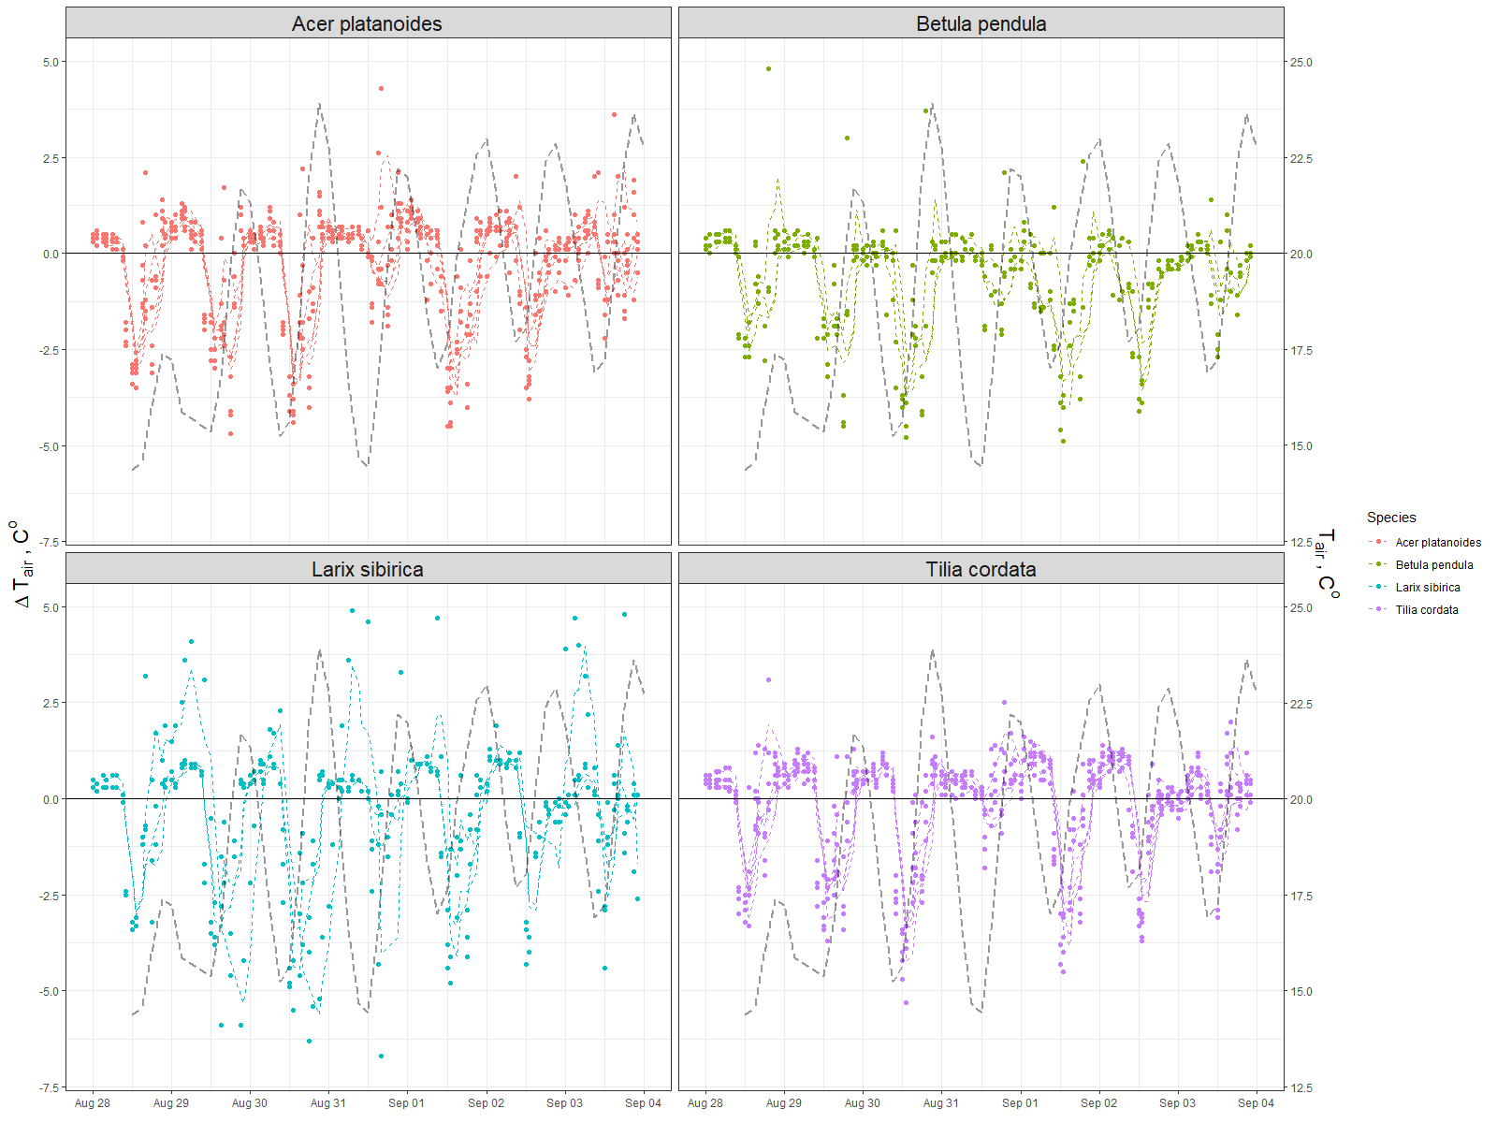

Appendix C. Daily example (top) and diurnal by month (bottom) dynamics of the air relative humidity (Rh) and the difference (dRh) under and outside of the canopy

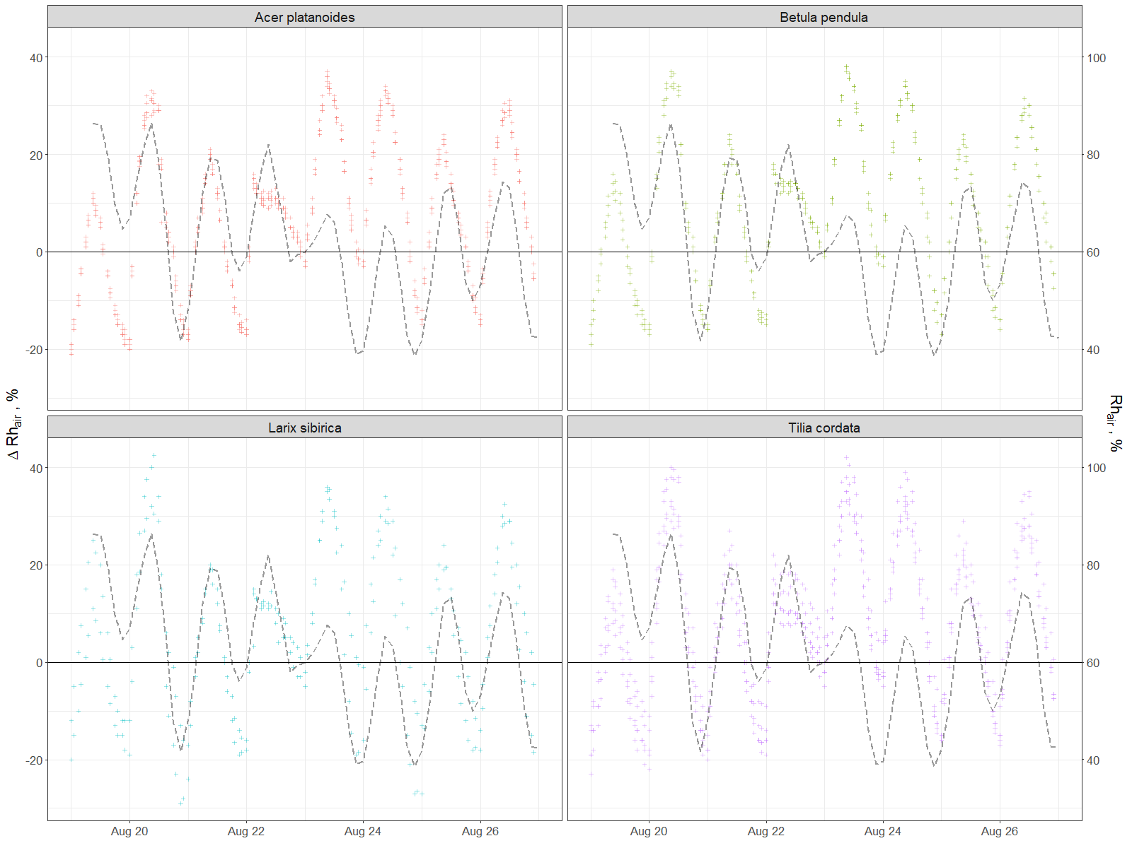

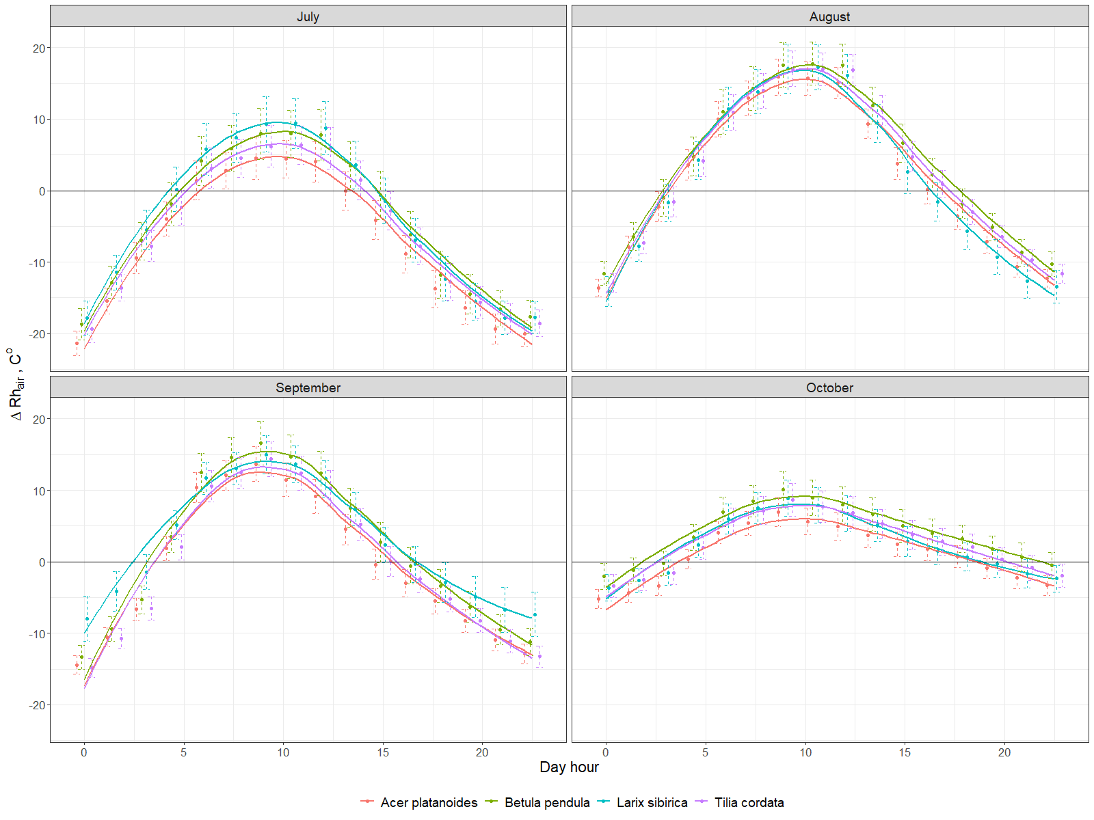

Appendix D. Example of flux dynamics per species for several days

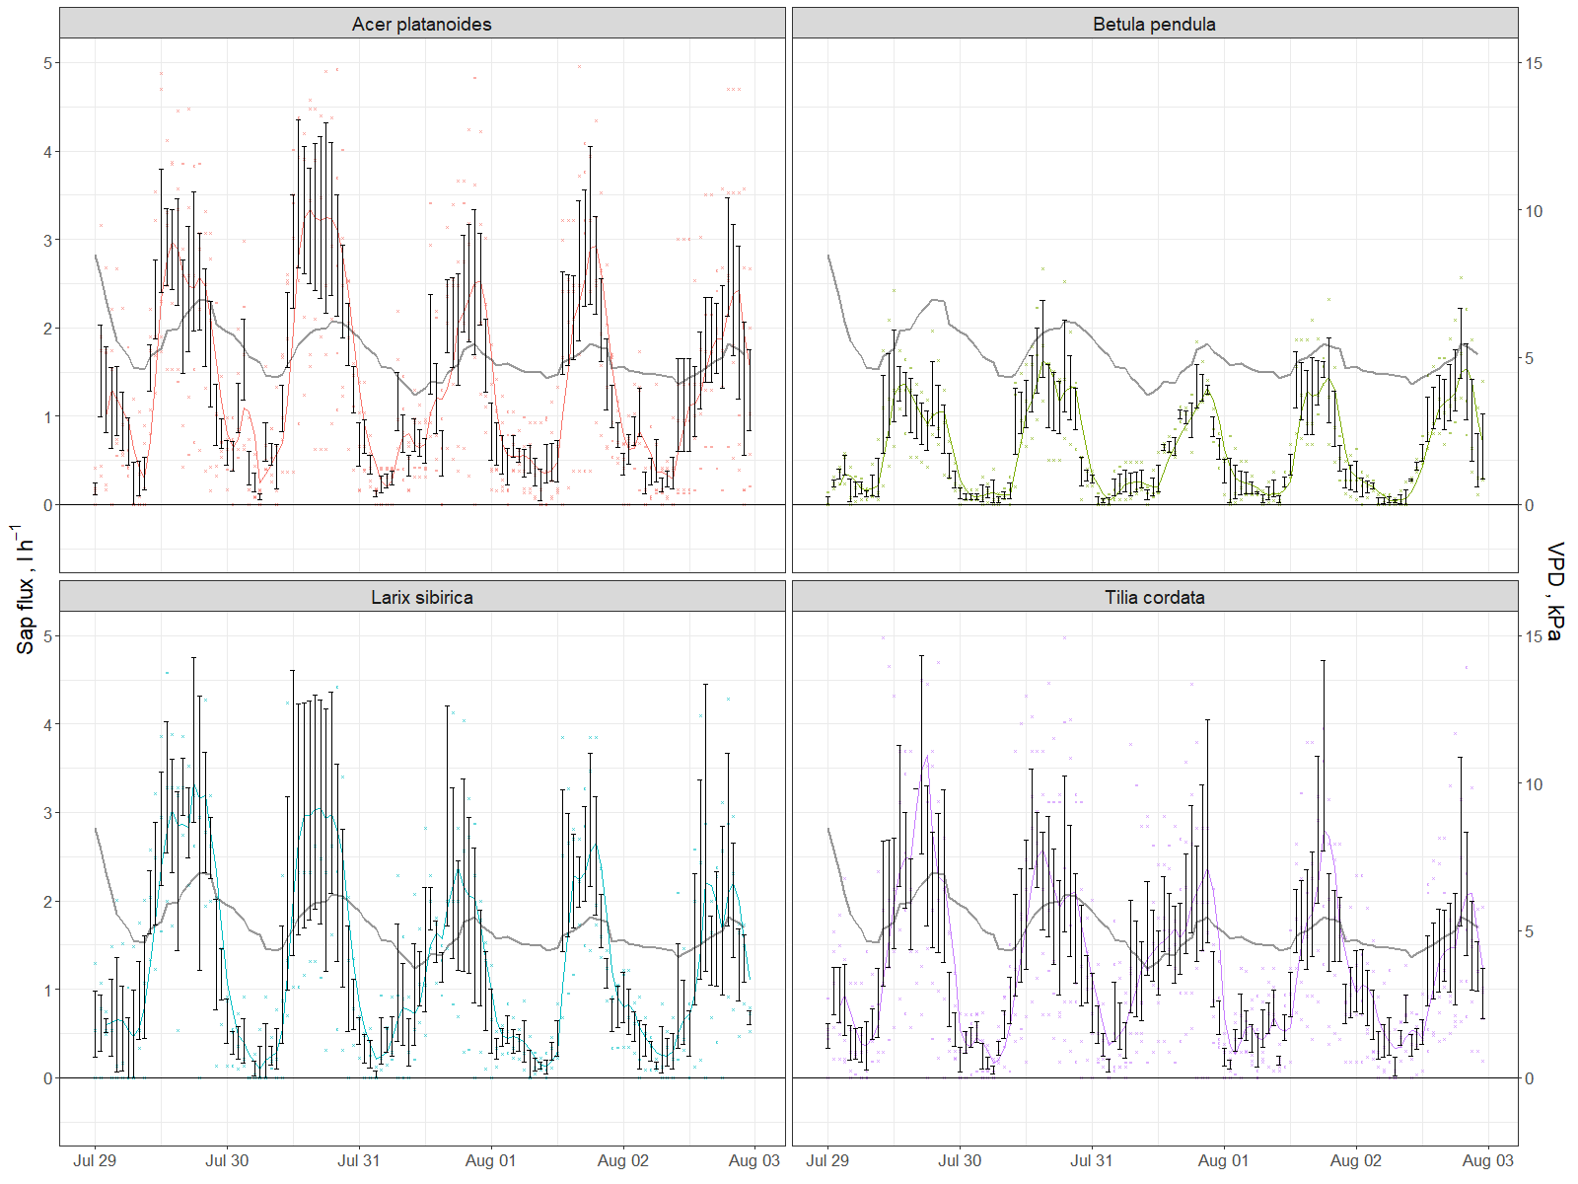

Appendix E. Energy removed from atmosphere monthly by each investigated tree

Appendix F. Dynamics of atmospheric particulate matter with diameter less than 10 micrometers (PM10) averaged daily concentration in air (dashed line) and amount of PM10 absorbed by investigated trees daily (line shows average value, while whiskers denote min and max)

New papers

Daley, Michael J., et al. "Water use by eastern hemlock (Tsuga canadensis) and black birch (Betula lenta): implications of effects of the hemlock woolly adelgid." *Canadian Journal of Forest Research* 37.10 (2007): 2031-2040.

Gebauer, Tobias, Viviana Horna, and Christoph Leuschner. "Variability in radial sap flux density patterns and sapwood area among seven co-occurring temperate broad-leaved tree species." *Tree physiology* 28.12 (2008): 1821-1830.

Thurner, Martin, et al. "Sapwood biomass carbon in northern boreal and temperate forests." *Global Ecology and Biogeography* 28.5 (2019): 640-660.

References

1. Dye, C. Health and Urban Living. *Science* **2008**, *319*, 766, doi:10.1126/science.1150198.

2. Bettencourt, L.M.A.; Lobo, J.; Helbing, D.; Kuhnert, C.; West, G.B. Growth, innovation, scaling, and the pace of life in cities. *Proc. Natl. Acad. Sci.* **2007**, *104*, 7301–7306, doi:10.1073/pnas.0610172104.

3. Frumkin, H. Healthy Places: Exploring the Evidence. *Am. J. Public Health* **2003**, *93*, 1451–1456, doi:10.2105/AJPH.93.9.1451.

4. Lederbogen, F.; Kirsch, P.; Haddad, L.; Streit, F.; Tost, H.; Schuch, P.; Wüst, S.; Pruessner, J.C.; Rietschel, M.; Deuschle, M.; et al. City living and urban upbringing affect neural social stress processing in humans. *Nature* **2011**, *474*, 498–501, doi:10.1038/nature10190.

5. Grimm, N.B.; Faeth, S.H.; Golubiewski, N.E.; Redman, C.L.; Wu, J.; Bai, X.; Briggs, J.M. Global Change and the Ecology of Cities. *Science* **2008**, *319*, 756, doi:10.1126/science.1150195.

6. Seto, K.C.; Guneralp, B.; Hutyra, L.R. Global forecasts of urban expansion to 2030 and direct impacts on biodiversity and carbon pools. *Proc. Natl. Acad. Sci.* **2012**, *109*, 16083–16088, doi:10.1073/pnas.1211658109.

7. Bolund, P.; Hunhammar, S. Ecosystem services in urban areas. *Ecol. Econ.* **1999**, *29*, 293–301, doi:10.1016/S0921-8009(99)00013-0.

8. Guo, Z.; Zhang, L.; Li, Y. Increased Dependence of Humans on Ecosystem Services and Biodiversity. *PLoS ONE* **2010**, *5*, e13113, doi:10.1371/journal.pone.0013113.

9. Krausmann, F.; Lauk, C.; Haas, W.; Wiedenhofer, D. From resource extraction to outflows of wastes and emissions: The socioeconomic metabolism of the global economy, 1900–2015. *Glob. Environ. Change* **2018**, *52*, 131–140, doi:10.1016/j.gloenvcha.2018.07.003.

10. Blanusa, T.; Garratt, M.; Cathcart-James, M.; Hunt, L.; Cameron, R.W.F. Urban hedges: A review of plant species and cultivars for ecosystem service delivery in north-west Europe. *Urban For. Urban Green.* **2019**, *44*, 126391, doi:10.1016/j.ufug.2019.126391.

11. Gómez-Baggethun, E.; Barton, D.N. Classifying and valuing ecosystem services for urban planning. *Ecol. Econ.* **2013**, *86*, 235–245, doi:10.1016/j.ecolecon.2012.08.019.

12. Lovell, S.T.; Taylor, J.R. Supplying urban ecosystem services through multifunctional green infrastructure in the United States. *Landsc. Ecol.* **2013**, *28*, 1447–1463, doi:10.1007/s10980-013-9912-y.

13. Neugarten, R.A.; Langhammer, P.F.; Osipova, E.; Bagstad, K.J.; Bhagabati, N.; Butchart, S.H.M.; Dudley, N.; Elliott, V.; Gerber, L.R.; Gutierrez Arrellano, C.; et al. *Tools for measuring, modelling, and valuing ecosystem services: guidance for Key Biodiversity Areas, natural World Heritage sites, and protected areas*; Groves, C., Ed.; 1st ed.; IUCN, International Union for Conservation of Nature, 2018; ISBN 978-2-8317-1917-7.

14. Zhao, C.; Sander, H.A. Assessing the sensitivity of urban ecosystem service maps to input spatial data resolution and method choice. *Landsc. Urban Plan.* **2018**, *175*, 11–22, doi:10.1016/j.landurbplan.2018.03.007.

15. Andersson, E.; Barthel, S.; Borgström, S.; Colding, J.; Elmqvist, T.; Folke, C.; Gren, Å. Reconnecting Cities to the Biosphere: Stewardship of Green Infrastructure and Urban Ecosystem Services. *AMBIO* **2014**, *43*, 445–453, doi:10.1007/s13280-014-0506-y.

16. Burkhard, B.; Maes, J.; Potschin-Young, M.; Santos-Martín, F.; Geneletti, D.; Stoev, P.; Kopperoinen, L.; Adamescu, C.; Adem Esmail, B.; Arany, I.; et al. Mapping and assessing ecosystem services in the EU - Lessons learned from the ESMERALDA approach of integration. *One Ecosyst.* **2018**, *3*, doi:10.3897/oneeco.3.e29153.

17. Mexia, T.; Vieira, J.; Príncipe, A.; Anjos, A.; Silva, P.; Lopes, N.; Freitas, C.; Santos-Reis, M.; Correia, O.; Branquinho, C.; et al. Ecosystem services: Urban parks under a magnifying glass. *Environ. Res.* **2018**, *160*, 469–478, doi:10.1016/j.envres.2017.10.023.

18. Nowak, D.J.; Hirabayashi, S.; Doyle, M.; McGovern, M.; Pasher, J. Air pollution removal by urban forests in Canada and its effect on air quality and human health. *Urban For. Urban Green.* **2018**, *29*, 40–48, doi:10.1016/j.ufug.2017.10.019.

19. van Oudenhoven, A.P.E.; Petz, K.; Alkemade, R.; Hein, L.; de Groot, R.S. Framework for systematic indicator selection to assess effects of land management on ecosystem services. *Ecol. Indic.* **2012**, *21*, 110–122, doi:10.1016/j.ecolind.2012.01.012.

20. Drobnik, T.; Greiner, L.; Keller, A.; Grêt-Regamey, A. Soil quality indicators – From soil functions to ecosystem services. *Ecol. Indic.* **2018**, *94*, 151–169, doi:10.1016/j.ecolind.2018.06.052.

21. Van Reeth, W. Ecosystem Service Indicators. In *Ecosystem Services*; Elsevier, 2013; pp. 41–61 ISBN 978-0-12-419964-4.

22. Czúcz, B.; Arany, I.; Potschin-Young, M.; Bereczki, K.; Kertész, M.; Kiss, M.; Aszalós, R.; Haines-Young, R. Where concepts meet the real world: A systematic review of ecosystem service indicators and their classification using CICES. *Ecosyst. Serv.* **2018**, *29*, 145–157, doi:10.1016/j.ecoser.2017.11.018.

23. Müller, F.; Burkhard, B. The indicator side of ecosystem services. *Ecosyst. Serv.* **2012**, *1*, 26–30, doi:10.1016/j.ecoser.2012.06.001.

24. van Oudenhoven, A.P.E.; Schröter, M.; Drakou, E.G.; Geijzendorffer, I.R.; Jacobs, S.; van Bodegom, P.M.; Chazee, L.; Czúcz, B.; Grunewald, K.; Lillebø, A.I.; et al. Key criteria for developing ecosystem service indicators to inform decision making. *Ecol. Indic.* **2018**, *95*, 417–426, doi:10.1016/j.ecolind.2018.06.020.

25. Willcock, S.; Hooftman, D.; Sitas, N.; O’Farrell, P.; Hudson, M.D.; Reyers, B.; Eigenbrod, F.; Bullock, J.M. Do ecosystem service maps and models meet stakeholders’ needs? A preliminary survey across sub-Saharan Africa. *Ecosyst. Serv.* **2016**, *18*, 110–117, doi:10.1016/j.ecoser.2016.02.038.

26. Alonzo, M.; Bookhagen, B.; Roberts, D.A. Urban tree species mapping using hyperspectral and lidar data fusion. *Remote Sens. Environ.* **2014**, *148*, 70–83, doi:10.1016/j.rse.2014.03.018.

27. Elliott, S. The potential for automating assisted natural regeneration of tropical forest ecosystems. *Biotropica* **2016**, *48*, 825–833, doi:10.1111/btp.12387.

28. Bauer, J.; Jarmer, T.; Schittenhelm, S.; Siegmann, B.; Aschenbruck, N. Processing and filtering of leaf area index time series assessed by in-situ wireless sensor networks. *Comput. Electron. Agric.* **2019**, *165*, 104867, doi:10.1016/j.compag.2019.104867.

29. Mesas-Carrascosa, F.J.; Verdú Santano, D.; Meroño, J.E.; Sánchez de la Orden, M.; García-Ferrer, A. Open source hardware to monitor environmental parameters in precision agriculture. *Biosyst. Eng.* **2015**, *137*, 73–83, doi:10.1016/j.biosystemseng.2015.07.005.

30. Farina, A.; James, P.; Bobryk, C.; Pieretti, N.; Lattanzi, E.; McWilliam, J. Low cost (audio) recording (LCR) for advancing soundscape ecology towards the conservation of sonic complexity and biodiversity in natural and urban landscapes. *Urban Ecosyst.* **2014**, *17*, 923–944, doi:10.1007/s11252-014-0365-0.

31. Mydlarz, C.; Sharma, M.; Lockerman, Y.; Steers, B.; Silva, C.; Bello, J. The Life of a New York City Noise Sensor Network. *Sensors* **2019**, *19*, 1415, doi:10.3390/s19061415.

32. Valentini, R.; Belelli Marchesini, L.; Gianelle, D.; Sala, G.; Yarovslavtsev, A.; Vasenev, V.; Castaldi, S. New tree monitoring systems: from Industry 4.0 to Nature 4.0. *Ann. Silvic. Res.* **2019**, *43*, doi:10.12899/asr-1847.

33. Vasenev, V.I.; Yaroslavtsev, A.M.; Vasenev, I.I.; Demina, S.A.; Dovltetyarova, E.A. Land-Use Change in New Moscow: First Outcomes after Five Years of Urbanization. *Geogr. Environ. Sustain.* **2019**, *12*, 24–34, doi:10.24057/2071-9388-2019-89.

34. Do, F.C.; Puangjumpa, N.; Rocheteau, A.; Duthoit, M.; Nhean, S.; Isarangkool Na Ayutthaya, S. Towards reduced heating duration in the transient thermal dissipation system of sap flow measurements. *Acta Hortic.* **2018**, 149–154, doi:10.17660/ActaHortic.2018.1222.31.

35. Andersson-Sköld, Y.; Klingberg, J.; Gunnarsson, B.; Cullinane, K.; Gustafsson, I.; Hedblom, M.; Knez, I.; Lindberg, F.; Ode Sang, Å.; Pleijel, H.; et al. A framework for assessing urban greenery’s effects and valuing its ecosystem services. *J. Environ. Manage.* **2018**, *205*, 274–285, doi:10.1016/j.jenvman.2017.09.071.

36. Nowak, D.J.; Crane, D.E. Carbon storage and sequestration by urban trees in the USA. *Environ. Pollut.* **2002**, *116*, 381–389, doi:10.1016/S0269-7491(01)00214-7.

37. Gratani, L.; Varone, L. Carbon sequestration by Quercus ilex L. and Quercus pubescens Willd. and their contribution to decreasing air temperature in Rome. *Urban Ecosyst.* **2006**, *9*, 27–37, doi:10.1007/s11252-006-5527-2.

38. Lindén, L.; Riikonen, A.; Setälä, H.; Yli-Pelkonen, V. Quantifying carbon stocks in urban parks under cold climate conditions. *Urban For. Urban Green.* **2020**, *49*, 126633, doi:10.1016/j.ufug.2020.126633.

39. Marando, F.; Salvatori, E.; Sebastiani, A.; Fusaro, L.; Manes, F. Regulating Ecosystem Services and Green Infrastructure: assessment of Urban Heat Island effect mitigation in the municipality of Rome, Italy. *Ecol. Model.* **2019**, *392*, 92–102, doi:10.1016/j.ecolmodel.2018.11.011.

40. Krayenhoff, E.S.; Jiang, T.; Christen, A.; Martilli, A.; Oke, T.R.; Bailey, B.N.; Nazarian, N.; Voogt, J.A.; Giometto, M.G.; Stastny, A.; et al. A multi-layer urban canopy meteorological model with trees (BEP-Tree): Street tree impacts on pedestrian-level climate. *Urban Clim.* **2020**, *32*, 100590, doi:10.1016/j.uclim.2020.100590.

41. Morakinyo, T.E.; Ouyang, W.; Lau, K.K.-L.; Ren, C.; Ng, E. Right tree, right place (urban canyon): Tree species selection approach for optimum urban heat mitigation - development and evaluation. *Sci. Total Environ.* **2020**, *719*, 137461, doi:10.1016/j.scitotenv.2020.137461.

42. Moghbel, M.; Erfanian Salim, R. Environmental benefits of green roofs on microclimate of Tehran with specific focus on air temperature, humidity and CO 2 content. *Urban Clim.* **2017**, *20*, 46–58, doi:10.1016/j.uclim.2017.02.012.

43. Chen, X.; Zhao, P.; Hu, Y.; Ouyang, L.; Zhu, L.; Ni, G. Canopy transpiration and its cooling effect of three urban tree species in a subtropical city- Guangzhou, China. *Urban For. Urban Green.* **2019**, *43*, 126368, doi:10.1016/j.ufug.2019.126368.

44. Lee, K.H.; Ehsani, R.; Castle, W.S. A laser scanning system for estimating wind velocity reduction through tree windbreaks. *Comput. Electron. Agric.* **2010**, *73*, 1–6, doi:10.1016/j.compag.2010.03.007.

45. Hefny Salim, M.; Heinke Schlünzen, K.; Grawe, D. Including trees in the numerical simulations of the wind flow in urban areas: Should we care? *J. Wind Eng. Ind. Aerodyn.* **2015**, *144*, 84–95, doi:10.1016/j.jweia.2015.05.004.

46. Kang, G.; Kim, J.-J.; Choi, W. Computational fluid dynamics simulation of tree effects on pedestrian wind comfort in an urban area. *Sustain. Cities Soc.* **2020**, *56*, 102086, doi:10.1016/j.scs.2020.102086.

47. Puzachenko, Y.; Sandlersky, R.; Sankovski, A. Methods of Evaluating Thermodynamic Properties of Landscape Cover Using Multispectral Reflected Radiation Measurements by the Landsat Satellite. *Entropy* **2013**, *15*, 3970–3982, doi:10.3390/e15093970.

48. Puzachenko, Yu.G.; Sandlersky, R.B.; Krenke, A.N.; Puzachenko, Yu.M. Multispectral remote information in forest research. *Contemp. Probl. Ecol.* **2014**, *7*, 838–854, doi:10.1134/S1995425514070087.

49. Marchionni, V.; Guyot, A.; Tapper, N.; Walker, J.P.; Daly, E. Water balance and tree water use dynamics in remnant urban reserves. *J. Hydrol.* **2019**, *575*, 343–353, doi:10.1016/j.jhydrol.2019.05.022.

50. Urban, J.; Rubtsov, A.V.; Urban, A.V.; Shashkin, A.V.; Benkova, V.E. Canopy transpiration of a Larix sibirica and Pinus sylvestris forest in Central Siberia. *Agric. For. Meteorol.* **2019**, *271*, 64–72, doi:10.1016/j.agrformet.2019.02.038.

51. Zölch, T.; Henze, L.; Keilholz, P.; Pauleit, S. Regulating urban surface runoff through nature-based solutions – An assessment at the micro-scale. *Environ. Res.* **2017**, *157*, 135–144, doi:10.1016/j.envres.2017.05.023.

52. Pereira, F.L.; Gash, J.H.C.; David, J.S.; Valente, F. Evaporation of intercepted rainfall from isolated evergreen oak trees: Do the crowns behave as wet bulbs? *Agric. For. Meteorol.* **2009**, *149*, 667–679, doi:10.1016/j.agrformet.2008.10.013.

53. Smets, V.; Wirion, C.; Bauwens, W.; Hermy, M.; Somers, B.; Verbeiren, B. The importance of city trees for reducing net rainfall: comparing measurements and simulations. *Hydrol. Earth Syst. Sci.* **2019**, *23*, 3865–3884, doi:10.5194/hess-23-3865-2019.

54. Valente, F.; Gash, J.H.; Nóbrega, C.; David, J.S.; Pereira, F.L. Modelling rainfall interception by an olive-grove/pasture system with a sparse tree canopy. *J. Hydrol.* **2020**, *581*, 124417, doi:10.1016/j.jhydrol.2019.124417.

55. Nowak, D.J.; Crane, D.E.; Stevens, J.C. Air pollution removal by urban trees and shrubs in the United States. *Urban For. Urban Green.* **2006**, *4*, 115–123, doi:10.1016/j.ufug.2006.01.007.

56. Hirabayashi, S.; Kroll, C.N.; Nowak, D.J. i-Tree Eco Dry Deposition Model Descriptions. **2012**, 36.

57. Sæbø, A.; Popek, R.; Nawrot, B.; Hanslin, H.M.; Gawronska, H.; Gawronski, S.W. Plant species differences in particulate matter accumulation on leaf surfaces. *Sci. Total Environ.* **2012**, *427–428*, 347–354, doi:10.1016/j.scitotenv.2012.03.084.

58. Schepaschenko, D.; Moltchanova, E.; Shvidenko, A.; Blyshchyk, V.; Dmitriev, E.; Martynenko, O.; See, L.; Kraxner, F. Improved Estimates of Biomass Expansion Factors for Russian Forests. *Forests* **2018**, *9*, 312, doi:10.3390/f9060312.

59. Granier, A. Une nouvelle méthode pour la mesure du flux de sève brute dans le tronc des arbres. *Ann. Sci. For.* **1985**, *42*, 193–200, doi:10.1051/forest:19850204.

60. Do, F.C.; Isarangkool Na Ayutthaya, S.; Rocheteau, A. Transient thermal dissipation method for xylem sap flow measurement: implementation with a single probe. *Tree Physiol.* **2011**, *31*, 369–380, doi:10.1093/treephys/tpr020.

61. Wang, X.; Liu, F.; Wang, C. Towards a standardized protocol for measuring leaf area index in deciduous forests with litterfall collection. *For. Ecol. Manag.* **2019**, *447*, 87–94, doi:10.1016/j.foreco.2019.05.050.

62. Yan, G.; Hu, R.; Luo, J.; Weiss, M.; Jiang, H.; Mu, X.; Xie, D.; Zhang, W. Review of indirect optical measurements of leaf area index: Recent advances, challenges, and perspectives. *Agric. For. Meteorol.* **2019**, *265*, 390–411, doi:10.1016/j.agrformet.2018.11.033.

63. Neinavaz, E.; Skidmore, A.K.; Darvishzadeh, R.; Groen, T.A. Retrieval of leaf area index in different plant species using thermal hyperspectral data. *ISPRS J. Photogramm. Remote Sens.* **2016**, *119*, 390–401, doi:10.1016/j.isprsjprs.2016.07.001.

64. R Core Team *R: A language and environment for statistical computing.*; R Foundation for Statistical Computing: Vienna, Austria, 2014;

65. Moser-Reischl, A.; Rahman, M.A.; Pauleit, S.; Pretzsch, H.; Rötzer, T. Growth patterns and effects of urban micro-climate on two physiologically contrasting urban tree species. *Landsc. Urban Plan.* **2019**, *183*, 88–99, doi:10.1016/j.landurbplan.2018.11.004.

66. Pretzsch, H.; Zenner, E.K. Toward managing mixed-species stands: from parametrization to prescription. *For. Ecosyst.* **2017**, *4*, doi:10.1186/s40663-017-0105-z.

67. Augustaitis, A.; Augustaitienė, I.; Baugarten, M.; Bičenkienė, S.; Girgždienė, R.; Kulbokas, G.; Linkevičius, E.; Marozas, V.; Mikalajūnas, M.; Mordas, G.; et al. Tree-ring formation as an indicator of forest capacity to adapt to the main threats of environmental changes in Lithuania. *Sci. Total Environ.* **2018**, *615*, 1247–1261, doi:10.1016/j.scitotenv.2017.09.169.

68. Augustaitis, A.; Augustaitiene, I.; Mozgeris, G.; Juknys, R.; Vitas, A.; Jasinevičiene, D. Growth patterns of Scots pine (Pinus sylvestris L.) under the current regional pollution load in Lithuania. *IForest - Biogeosciences For.* **2015**, *8*, 509–516, doi:10.3832/ifor1267-007.

69. Rahman, M.A.; Stratopoulos, L.M.F.; Moser-Reischl, A.; Zölch, T.; Häberle, K.-H.; Rötzer, T.; Pretzsch, H.; Pauleit, S. Traits of trees for cooling urban heat islands: A meta-analysis. *Build. Environ.* **2020**, *170*, 106606, doi:10.1016/j.buildenv.2019.106606.

70. Buccolieri, R.; Santiago, J.-L.; Rivas, E.; Sáanchez, B. Reprint of: Review on urban tree modelling in CFD simulations: Aerodynamic, deposition and thermal effects. *Urban For. Urban Green.* **2019**, *37*, 56–64, doi:10.1016/j.ufug.2018.07.004.

71. Kremer, P.; Hamstead, Z.A.; McPhearson, T. The value of urban ecosystem services in New York City: A spatially explicit multicriteria analysis of landscape scale valuation scenarios. *Environ. Sci. Policy* **2016**, *62*, 57–68, doi:10.1016/j.envsci.2016.04.012.

72. Tonyaloğlu, E.E. Spatiotemporal dynamics of urban ecosystem services in Turkey: The case of Bornova, Izmir. *Urban For. Urban Green.* **2020**, *49*, 126631, doi:10.1016/j.ufug.2020.126631.

73. Moser, A.; Rötzer, T.; Pauleit, S.; Pretzsch, H. Structure and ecosystem services of small-leaved lime (Tilia cordata Mill.) and black locust (Robinia pseudoacacia L.) in urban environments. *Urban For. Urban Green.* **2015**, *14*, 1110–1121, doi:10.1016/j.ufug.2015.10.005.

74. Riikonen, A.; Järvi, L.; Nikinmaa, E. Environmental and crown related factors affecting street tree transpiration in Helsinki, Finland. *Urban Ecosyst.* **2016**, *19*, 1693–1715, doi:10.1007/s11252-016-0561-1.

75. Livesley, S.J.; McPherson, E.G.; Calfapietra, C. The Urban Forest and Ecosystem Services: Impacts on Urban Water, Heat, and Pollution Cycles at the Tree, Street, and City Scale. *J. Environ. Qual.* **2016**, *45*, 119–124, doi:10.2134/jeq2015.11.0567.

76. Scharenbroch, B.C.; Morgenroth, J.; Maule, B. Tree Species Suitability to Bioswales and Impact on the Urban Water Budget. *J. Environ. Qual.* **2016**, *45*, 199–206, doi:10.2134/jeq2015.01.0060.

77. Xiao, Q.; McPherson, E.G. Surface Water Storage Capacity of Twenty Tree Species in Davis, California. *J. Environ. Qual.* **2016**, *45*, 188–198, doi:10.2134/jeq2015.02.0092.

78. Prasad Ghimire, C.; Adrian Bruijnzeel, L.; Lubczynski, M.W.; Ravelona, M.; Zwartendijk, B.W.; van Meerveld, H.J. (Ilja) Measurement and modeling of rainfall interception by two differently aged secondary forests in upland eastern Madagascar. *J. Hydrol.* **2017**, *545*, 212–225, doi:10.1016/j.jhydrol.2016.10.032.

79. Syrbe, R.-U.; Schorcht, M.; Grunewald, K.; Meinel, G. Indicators for a nationwide monitoring of ecosystem services in Germany exemplified by the mitigation of soil erosion by water. *Ecol. Indic.* **2018**, *94*, 46–54, doi:10.1016/j.ecolind.2017.05.035.

80. Bremer, M.; Wichmann, V.; Rutzinger, M. Calibration and Validation of a Detailed Architectural Canopy Model Reconstruction for the Simulation of Synthetic Hemispherical Images and Airborne LiDAR Data. *Remote Sens.* **2017**, *9*, 220, doi:10.3390/rs9030220.

81. Taheriazad, L.; Moghadas, H.; Sanchez-Azofeifa, A. Calculation of leaf area index in a Canadian boreal forest using adaptive voxelization and terrestrial LiDAR. *Int. J. Appl. Earth Obs. Geoinformation* **2019**, *83*, 101923, doi:10.1016/j.jag.2019.101923.

82. Zhu, X.; Skidmore, A.K.; Wang, T.; Liu, J.; Darvishzadeh, R.; Shi, Y.; Premier, J.; Heurich, M. Improving leaf area index (LAI) estimation by correcting for clumping and woody effects using terrestrial laser scanning. *Agric. For. Meteorol.* **2018**, *263*, 276–286, doi:10.1016/j.agrformet.2018.08.026.

83. Klingberg, J.; Konarska, J.; Lindberg, F.; Johansson, L.; Thorsson, S. Mapping leaf area of urban greenery using aerial LiDAR and ground-based measurements in Gothenburg, Sweden. *Urban For. Urban Green.* **2017**, *26*, 31–40, doi:10.1016/j.ufug.2017.05.011.

84. Wang, R.; Chen, J.M.; Luo, X.; Black, A.; Arain, A. Seasonality of leaf area index and photosynthetic capacity for better estimation of carbon and water fluxes in evergreen conifer forests. *Agric. For. Meteorol.* **2019**, *279*, 107708, doi:10.1016/j.agrformet.2019.107708.

85. Muhammad, S.; Wuyts, K.; Samson, R. Atmospheric net particle accumulation on 96 plant species with contrasting morphological and anatomical leaf characteristics in a common garden experiment. *Atmos. Environ.* **2019**, *202*, 328–344, doi:10.1016/j.atmosenv.2019.01.015.

86. Bottalico, F.; Chirici, G.; Giannetti, F.; De Marco, A.; Nocentini, S.; Paoletti, E.; Salbitano, F.; Sanesi, G.; Serenelli, C.; Travaglini, D. Air Pollution Removal by Green Infrastructures and Urban Forests in the City of Florence. *Agric. Agric. Sci. Procedia* **2016**, *8*, 243–251, doi:10.1016/j.aaspro.2016.02.099.

87. Selmi, W.; Weber, C.; Rivière, E.; Blond, N.; Mehdi, L.; Nowak, D. Air pollution removal by trees in public green spaces in Strasbourg city, France. *Urban For. Urban Green.* **2016**, *17*, 192–201, doi:10.1016/j.ufug.2016.04.010.

88. Doser, J.W.; Finley, A.O.; Kasten, E.P.; Gage, S.H. Assessing soundscape disturbance through hierarchical models and acoustic indices: A case study on a shelterwood logged northern Michigan forest. *Ecol. Indic.* **2020**, *113*, 106244, doi:10.1016/j.ecolind.2020.106244.

89. Margaritis, E.; Kang, J.; Filipan, K.; Botteldooren, D. The influence of vegetation and surrounding traffic noise parameters on the sound environment of urban parks. *Appl. Geogr.* **2018**, *94*, 199–212, doi:10.1016/j.apgeog.2018.02.017.

90. Nitoslawski, S.A.; Galle, N.J.; Van Den Bosch, C.K.; Steenberg, J.W.N. Smarter ecosystems for smarter cities? A review of trends, technologies, and turning points for smart urban forestry. *Sustain. Cities Soc.* **2019**, *51*, 101770, doi:10.1016/j.scs.2019.101770.

91. Schröter, M.; Kraemer, R.; Mantel, M.; Kabisch, N.; Hecker, S.; Richter, A.; Neumeier, V.; Bonn, A. Citizen science for assessing ecosystem services: Status, challenges and opportunities. *Ecosyst. Serv.* **2017**, *28*, 80–94, doi:10.1016/j.ecoser.2017.09.017.

92. Cortinovis, C.; Geneletti, D. A framework to explore the effects of urban planning decisions on regulating ecosystem services in cities. *Ecosyst. Serv.* **2019**, *38*, 100946, doi:10.1016/j.ecoser.2019.100946.

93. Bodnaruk, E.W.; Kroll, C.N.; Yang, Y.; Hirabayashi, S.; Nowak, D.J.; Endreny, T.A. Where to plant urban trees? A spatially explicit methodology to explore ecosystem service tradeoffs. *Landsc. Urban Plan.* **2017**, *157*, 457–467, doi:10.1016/j.landurbplan.2016.08.016.

94. Speak, A.; Escobedo, F.J.; Russo, A.; Zerbe, S. An ecosystem service-disservice ratio: Using composite indicators to assess the net benefits of urban trees. *Ecol. Indic.* **2018**, *95*, 544–553, doi:10.1016/j.ecolind.2018.07.048.

95. Teixeira, F.Z.; Bachi, L.; Blanco, J.; Zimmermann, I.; Welle, I.; Carvalho-Ribeiro, S.M. Perceived ecosystem services (ES) and ecosystem disservices (EDS) from trees: insights from three case studies in Brazil and France. *Landsc. Ecol.* **2019**, *34*, 1583–1600, doi:10.1007/s10980-019-00778-y.

|  |  |
| --- | --- |
| copyRight | © 2020 by the authors. Submitted for possible open access publication under the terms and conditions of the Creative Commons Attribution (CC BY) license (http://creativecommons.org/licenses/by/4.0/). |